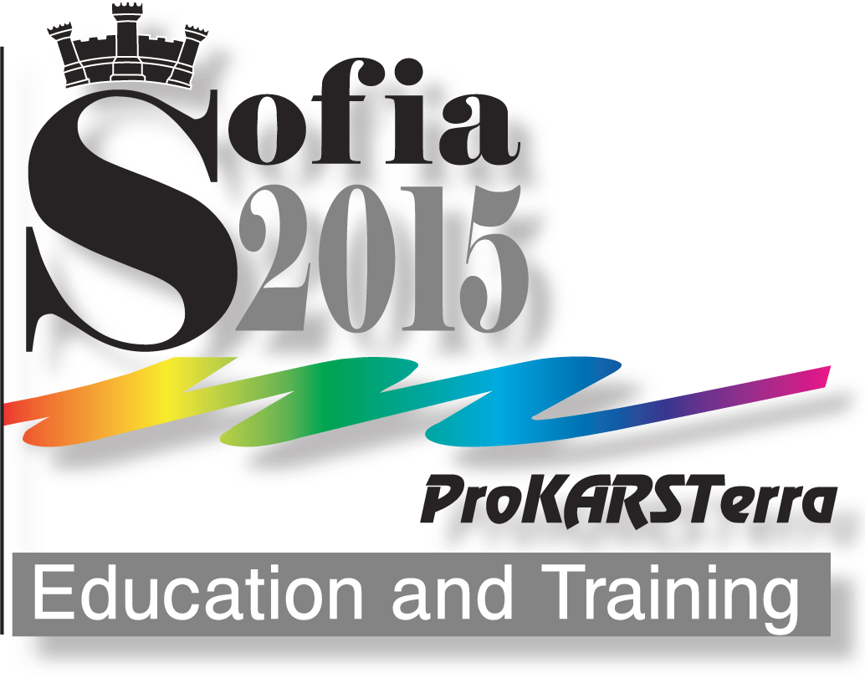 | REQUEST FOR PARTICIPATION  (Deadline: June 28, 2015)

Name: ..................................................... Surname: ...........................................................

Organizatioin: ............................................................................................................................

City: ........................................................ Country: ............................................................

E-mail: ............................................................................................................................................

Form of participation (please mark):
With paper
□ presentation
□ poster

□ Without paper (Listener)
□ Corporate presentation

In the exhibition ProKARSTerra`2015
□ Film(s) (please specify how many in the square)
□ Photograph(s) (please write the number of pictures in the square)
□ Book(s) (please specify how many in the square)
□ Other information materials (please indicate more specific): ….…...….……..
□ Picture and paintings (please specify how many in the square)
□ Art-installation (please indicate its character): .................................................
□ Special apparatuses (please indicate more specifically): ...................................

Thematic field (please mark):
□ Karst and integration between science and education
□ Place and role of protected karst territories (PKT) in education and training
□ Didactic and pedagogical significance of karst in school education
□ Karst in the legal framework of schooling
□ Karst in University education
□ Training about karst in system of speleological organizations (federations, associations, caving clubs)
□ Training about karst in management and control of karst territories
□ Application of Information and Communication technologies in education and training about karst:
□ Karst and UNESCO
□ Promotion of karst
□ Karst in preschool education – challenges, opinions, practices
□ Integrated education of disabled people in karst environment

Round table - International initiatives:
□ Karst Olympiad
□ Year of Karst and Caves

PAPER
Full title: .........................................................................................................................................
...........................................................................................................................................................
...........................................................................................................................................................

Author/s (Organizatioin, E-mail)
1. ....................................................................................................................................................
2. .....................................................................................................................................................
3. .....................................................................................................................................................

Abstract (50-100 words): .............................................................................................................
...........................................................................................................................................................
...........................................................................................................................................................
...........................................................................................................................................................
...........................................................................................................................................................
...........................................................................................................................................................
...................................................................................................................................................................................................................................................................................................................................................................................................................................................................................................................................................................................................................................................................................................................................................................................................................................................................................................................................................................................................................................................................................................................................................................................................................................................................................................................................................................................................................................................

Key words (to 5): .............................................................................................................................
...........................................................................................................................................................

Participation in field trips after the Conference (September 27-30, 2015) (please mark):
□ Yes
□ No

Use of working language(s) of the conference (please mark):
□ English
□ Russian
□ Bulgarian

Date: ................

Please fill your Request form and send to one of the following E-mail addresses:
forum2015@prokarstterra.bas.bg or forum2015@abv.bg

